Consider the below signal of the horizontal tide in a tidal basin.

The velocities are defined positive in wave propagation direction.

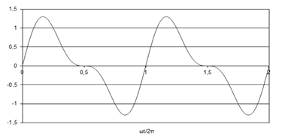

*What is the direction of the net tide-averaged transport of normal to coarse sediment?*

|  |  |  |
| --- | --- | --- |
|  |  | landward directed |
|  |  | seaward directed |
|  |  | no net transport |

In the following picture, the horizontal tide is shown as the sum of M2 and M4 tidal constituents: *u*(*t*)=*ûM2*cos(*ωM2t*)+*ûM4*cos(*ωM4t*-*φ*)  .

The velocity axis is positive upward and velocities are defined positive in wave propagation direction. The time axis is positive to the right.

|  |  |  |  |  |  |  |  |
| --- | --- | --- | --- | --- | --- | --- | --- |
|  | <https://mapleta-bsprod1.tudelft.nl:8443/mapleta/web/Cie4305000/Public_Html/HorTide1.png> |  |  |  |  |  |  |

[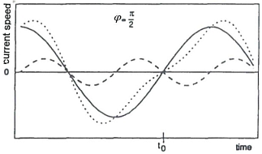](https://mapleta-bsprod1.tudelft.nl:8443/mapleta/web/Cie4305000/Public_Html/HorTide2.png)

[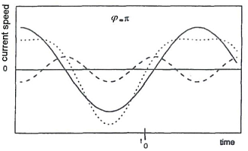](https://mapleta-bsprod1.tudelft.nl:8443/mapleta/web/Cie4305000/Public_Html/HorTide3.png)

[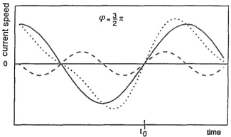](https://mapleta-bsprod1.tudelft.nl:8443/mapleta/web/Cie4305000/Public_Html/HorTide4.png)  
   
*Of the four above resulting velocity signals (dotted lines) which one gives rise to the export of normal to coarse sediment out of a basin?*

As a result of the tidal flow being diverted around a long shore-normal breakwater, the streamlines of the tidal flow will exhibit a certain curvature.

Due to this curvature, a secondary current may be expected.

*Such a secondary current:*

|  |  |  |
| --- | --- | --- |
|  |  | is directed along the streamlines of the tidal flow |
|  |  | is directed normal to the streamlines, with more or less onshore velocities near the bed |
|  |  | none of the other answers |
|  |  | is directed normal to the streamlines, with more or less offshore velocities near the bed |

The below hypsometric curves for two different basin types show the wetted basin surface area O(z) as a function of the water level.

|  |  |  |  |
| --- | --- | --- | --- |
|  | https://mapleta-bsprod1.tudelft.nl:8443/mapleta/web/Cie4305000/Public_Html/hypsoLeft.png |  | https://mapleta-bsprod1.tudelft.nl:8443/mapleta/web/Cie4305000/Public_Html/hypsoRight.png |

*Which of the two basin types is more likely to result in sediment import of normal to coarse sediment?*

Consider a short tidal basin in dynamic equilibrium.

The flood-tidal delta spans the entire basin area.

Now suppose that a relatively shallow part of the basin is reclaimed, reducing the basin area with a certain percentage.

Immediately after the closure the tidal flats are already more or less in equilibrium.

*Relatively short after the closure:*

|  |  |  |
| --- | --- | --- |
|  |  | the tidal velocity signal in the inlet gorge has become more ebb-dominant: TRUE |
|  |  | the tidal velocity signal in the inlet gorge has become more ebb-dominant: FALSE |
|  |  | the ebb-tidal delta is eroding: TRUE |
|  |  | the ebb-tidal delta is eroding: FALSE |

Escoffier’s model for inlet stability is depicted in the below figure.

On the horizontal axis is the entrance cross-section and on the vertical axis is the maximum cross-sectionally averaged velocity in the inlet.

The velocity *ue* is the equilibrium inlet velocity and three different closure curves are shown.

The dots indicate equilibrium conditions.

Escoffiers model can be seen as a morphodynamic model for the entrance of tidal basins.

The perturbation of an equilibrium may either result in positive or negative feedback.

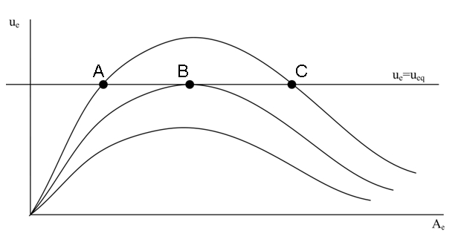

|  |  |  |
| --- | --- | --- |
|  |  | Point A represents a condition of stable equilibrium: TRUE |
|  |  | Point A represents a condition of stable equilibrium: FALSE |
|  |  | For Point B equilibrium relationships relating the cross-sectional inlet area to the tidal prism CANNOT be expected to hold: TRUE |
|  |  | For Point B equilibrium relationships relating the cross-sectional inlet area to the tidal prism CANNOT be expected to hold: FALSE |
|  |  | Point C shows an equilibrium condition that leads to positive feedback: TRUE |
|  |  | Point C shows an equilibrium condition that leads to positive feedback: FALSE |

Escoffier’s model for inlet stability is depicted in the below figure.

On the horizontal axis is the entrance cross-section and on the vertical axis is the maximum cross-sectionally averaged velocity in the inlet.

The velocity *ueq* is the equilibrium inlet velocity.

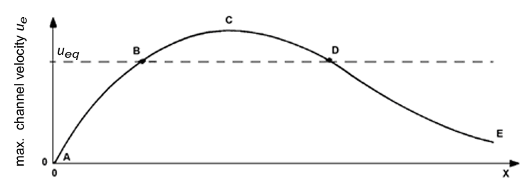

Now consider an inlet system in dynamic equilibrium.

In order to accommodate larger ships there is a wish to obtain a larger stable cross-section.

*Of the below options, what is a workable engineering solution?*

|  |  |  |
| --- | --- | --- |
|  |  | Slightly enlarge the cross-section by dredging such that it is at section B-C-D. Nature will now further enlarge it. |
|  |  | Enlarge the cross-section and at the same time build hard structures that move point D to the right. |
|  |  | Enlarge the cross-section by dredging until the desired size. Nature will maintain this enlarged cross-section. |

A basin is in dynamic equilibrium.

At some point in time, part of the basin is closed off by a dam.

The closure did not affect the tidal prism.

However, the dynamic equilibrium of the basin was disturbed in such a way that the basin started importing sediment.

*What will after some time be the effect of the closure, if any, on the adjacent coastlines?*

|  |  |  |
| --- | --- | --- |
|  |  | Erosion of the updrift coastline |
|  |  | Accretion of the updrift coastline |
|  |  | Erosion of the downdrift coastline |
|  |  | Accretion of the downdrift coastline |
|  |  | No effect |

The below picture shows a sketch of the morphological units of a tidal inlet system at a barrier island coast.

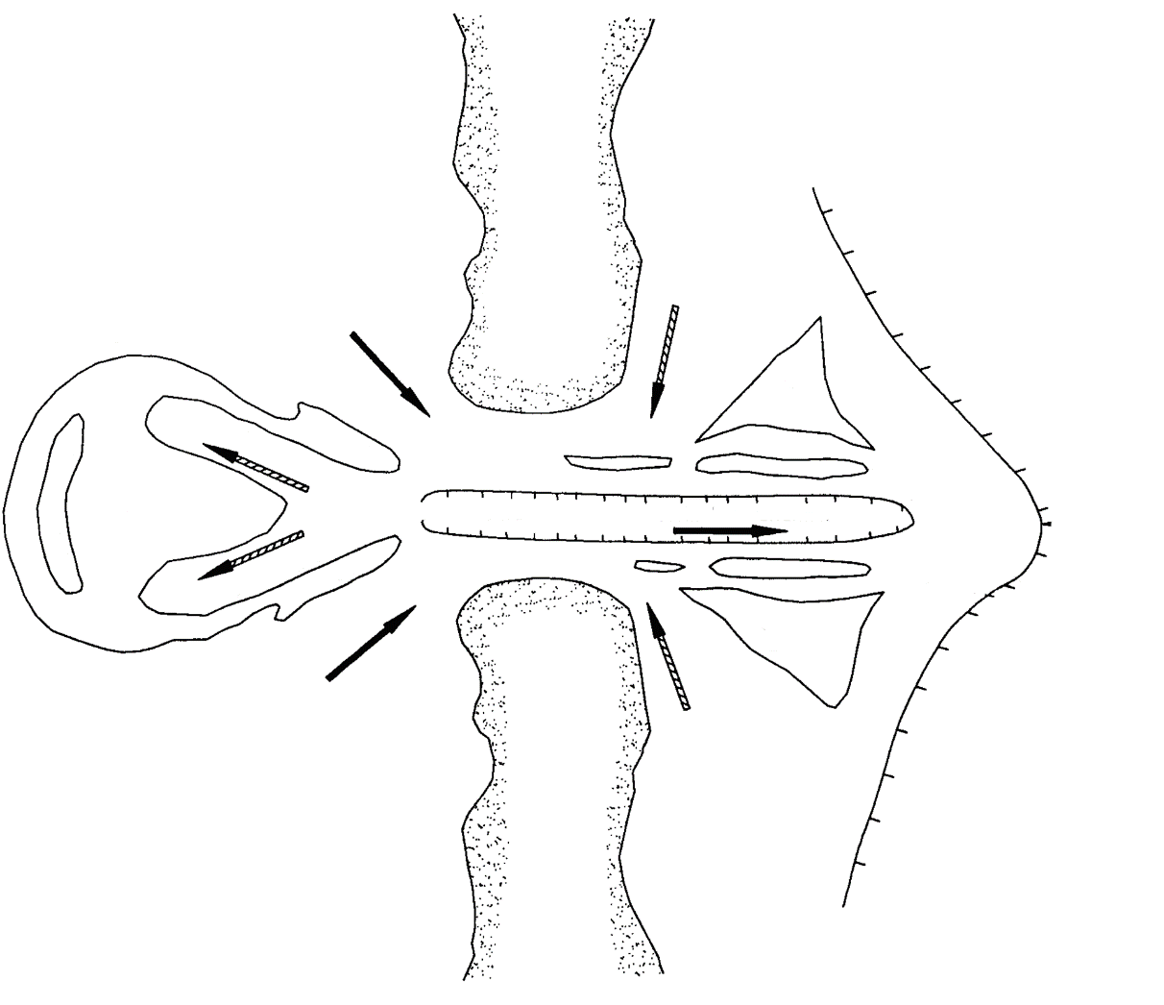

*Which arrows indicate flood flow?*

|  |  |  |
| --- | --- | --- |
|  |  | Solid arrows |
|  |  | Hashed arrows |

Consider an inlet system in dynamic equilibrium.

It consist of a short basin and an inlet gorge connecting the basin to the sea.

The basin has hardly any intertidal areas.

There are plans to reclaim part of the basin area.

How will the inlet gorge be affected?

*The inlet gorge will:*

|  |  |  |
| --- | --- | --- |
|  |  | erode until a new stable equilibrium is reached. |
|  |  | accrete until a new stable equilibrium is reached. |
|  |  | accrete or erode depending on the surface area of the reclamation |
|  |  | accrete until the inlet gorge is completely closed off. |